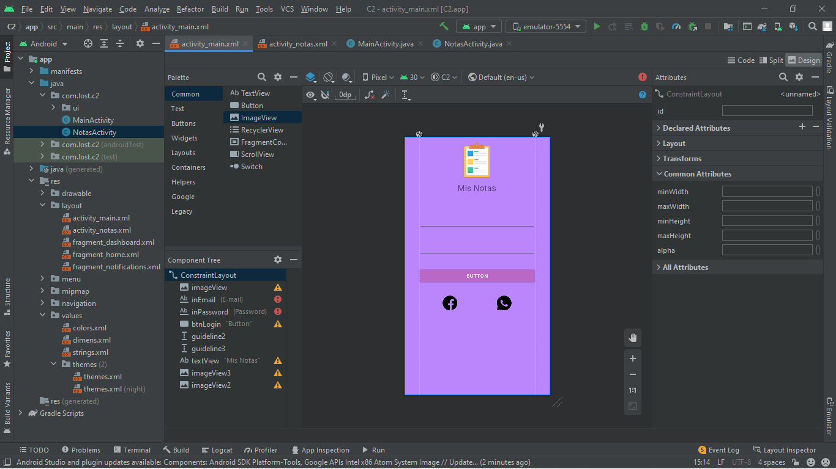
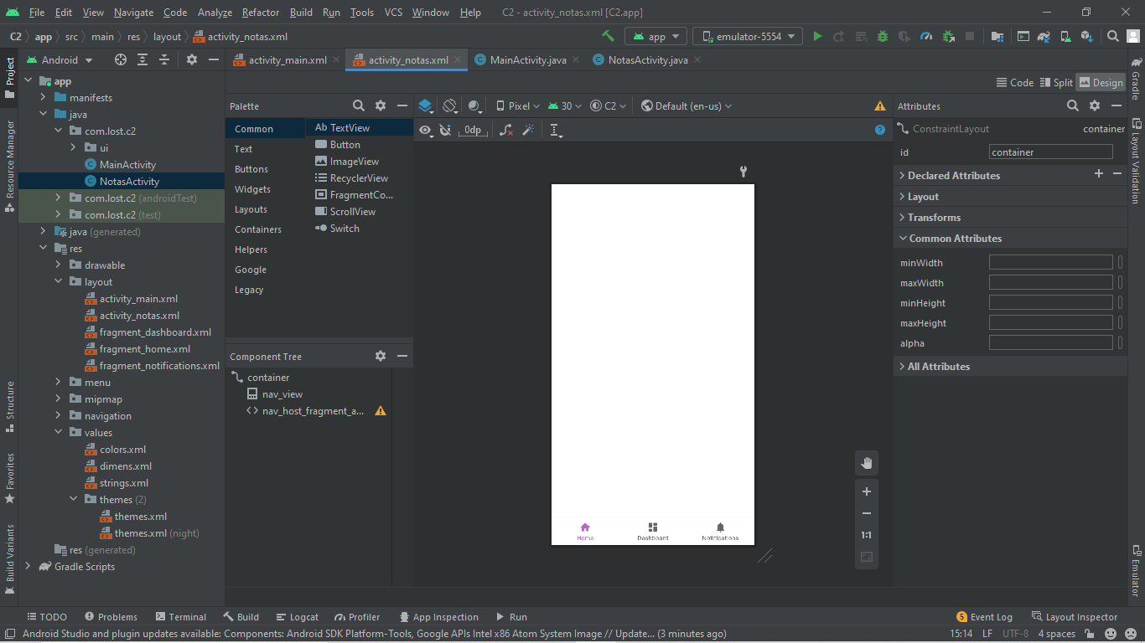

package com.lost.c2;
import androidx.appcompat.app.AppCompatActivity;
import android.content.Intent;
import android.os.Bundle;
import android.view.View;
import android.widget.Button;
public class MainActivity extends AppCompatActivity {
Button btnLogin;
@Override
protected void onCreate(Bundle savedInstanceState) {
super.onCreate(savedInstanceState);
setContentView(R.layout.activity_main);
btnLogin = findViewById(R.id.btnLogin);
btnLogin.setOnClickListener(view -> {
Intent intent = new Intent(MainActivity.this, NotasActivity.class);
startActivity(intent);
});
}
}

package com.lost.c2;
import android.os.Bundle;
import com.google.android.material.bottomnavigation.BottomNavigationView;
import androidx.appcompat.app.AppCompatActivity;
import androidx.navigation.NavController;
import androidx.navigation.Navigation;
import androidx.navigation.ui.AppBarConfiguration;
import androidx.navigation.ui.NavigationUI;
import com.lost.c2.databinding.ActivityNotasBinding;
public class NotasActivity extends AppCompatActivity {
private ActivityNotasBinding binding;
@Override
protected void onCreate(Bundle savedInstanceState) {
super.onCreate(savedInstanceState);
binding = ActivityNotasBinding.inflate(getLayoutInflater());
setContentView(binding.getRoot());
BottomNavigationView navView = findViewById(R.id.nav_view);
// Passing each menu ID as a set of Ids because each
// menu should be considered as top level destinations.
AppBarConfiguration appBarConfiguration = new AppBarConfiguration.Builder(
R.id.navigation_home, R.id.navigation_dashboard, R.id.navigation_notifications)
.build();
NavController navController = Navigation.findNavController(this, R.id.nav_host_fragment_activity_notas);
NavigationUI.setupActionBarWithNavController(this, navController, appBarConfiguration);
NavigationUI.setupWithNavController(binding.navView, navController);
}
}

